CUR8 LEARNING PROJECT TEMPLATE
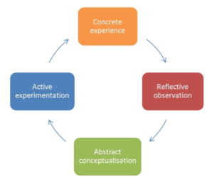
The Cur8 Learning Project is intended to help you reflect on the learning you have experienced/are experiencing and to help you transfer learning into practice and further develop your competence in Curation and the Facilitation of Online/Digital Learning. It will help you to complete the ‘learning cycle’ with active experimentation and concrete experience.
By setting goals for what you want to learn, as well as do, you will increase the impact of your experience, and enable you to reflect more specifically on your competence development.
- What will be the Context for your Learning Project? (e.g. CVET, AE, workplace etc.)
- What will be your Target Group(s)
- Description: Outline what you plan to do and why
- What are your personal learning objectives for doing this?
- Which Cur8 Activities/Methods /Processes do you think you might apply?

- Anticipated Results/ Impact.
How will you assess the the effectiveness and impact of your ‘intervention’?
- Timeframe for your project
- Which competence(s) are you aiming to improve or develop?

- How will you evaluate your progress at the end of the learning project?

